FRESH HARVEST FOODS CASE STUDY
PROJECT REPORT
INTRODUCTION TO THE BUSINESS

FreshHarvest Foods Ltd. is a mid-sized U.S.-based food processing company founded in 2004, specializing in packaged organic frozen meals, soups, and vegetable mixes. Over the years, it has grown into a nationally recognized brand known for sustainable sourcing, clean-label products, and smart packaging innovation. With USDA Organic and Non-GMO certifications, the company serves health-conscious consumers, millennials, and institutional clients through partnerships with retailers like Whole Foods and Trader Joe’s. Its competitive edge lies in clean processing, direct-from-farm sourcing, and robust cold-chain logistics.
PROBLEM STATEMENT
CASE STUDY OVERVIEW
Despite maintaining stringent quality control standards, FreshHarvest has faced a recurring issue of defective product batches.
SPECIFIC OBSTACLES:
1. Lack of batch-level traceability for raw material sources and processing
shifts.
2. Inconsistent machine calibration logs leading to improper cooking times.
3. Delayed defect detection (often after full production).
4. Manual QC logs with missing or incorrect data.
5. Difficulty identifying patterns in defective batches across time, teams, or suppliers. This has led to customer complaints, product recalls, and increased operational
costs due to waste and rework.
RATIONALE FOR THE PROJECT
Root Cause Analysis (RCA) in food processing is the process of identifying the underlying reasons for batch failures or quality deviations. This initiative aims to improve process transparency, enhance defect prediction, and proactively manage quality across production lines.

TOP 5 REASONS FOR INITIATING THIS PROJECT:
1. Reduce Financial Losses from defective batches, returns, and rework.
2. Protect Brand Reputation by minimizing the chances of recalls and bad publicity.
3. Enable Traceability & Compliance with food safety regulations (e.g., FDA FSMA).
4. Optimize Production Efficiency by identifying weak points in the processing lin
5. Improve Decision-Making through dashboards and data-driven insights.
OTHERS
6.Identify root causes of batch defects using historical production, quality, and sensor data.
7.Build a traceability model from raw material procurement to final packaging.
8. Develop an RCA dashboard in Power BI with alerts and trend insights.
9.Improve process parameters by linking defects to machine logs and operator shifts.
CASE STUDY OBJECTIVES
DATA DESCRIPTION

Production_Batch_Log
1. Batch_ID: Unique identifier for each production batch.
2. Product_Code: Code representing the specific product
type.
3. Start_Time: Timestamp when the batch processing
started.

4. End_Time: Timestamp when the batch processing ended.
5. Shift: Shift during which the batch was processed
(Morning, Evening, Night).

6. Operator_ID: ID of the operator responsible for the batch.
7. Line_Number: Production line number used.
8. Batch_Duration_Hours: Calculated duration of the batch
in hours.

QC_Inspection_Log
1. Inspection_ID: Unique identifier for each quality
inspection.
2. Batch_ID: ID linking the inspection to a specific
production batch.
3. Test_Type: Type of test conducted (e.g., Texture, pH,
Microbial).
4. Result: Result of the test (Pass or Fail).
5. Inspection_Time: Timestamp when the inspection was
conducted.
6. Inspector_ID: ID of the inspector who conducted the
test.
7. Week: ISO calendar week of the inspection for trend
analysis.

Data Description

Raw_Material_Trace
1. Material_ID: Unique identifier for raw material entry.
2. Supplier_ID: ID of the supplier who provided the
material.

3. Batch_ID: Production batch in which the material was
used.

4. Received_Date: Date the raw material was received.
5. Material_Type: Type of raw material (e.g., Carrots,
Peas).

6. Quality_Grade: Quality grade of the material (A, B, C).
7. Defective: Boolean indicating if the material was used
in a defective batch.

Machine_Sensor_Log
1. Sensor_ID: Unique identifier for sensor log entry.
2. Timestamp: Timestamp of the sensor reading.
3. Line_Number: Production line number the sensor is
monitoring.
4. Temperature: Measured temperature at the time of
reading.
5. Pressure: Measured pressure at the time of reading.
6. Speed: Operational speed of the equipment.
7. Status: Sensor status (e.g., OK, Overheat).
8. Batch_ID: Linked production batch based on time and
line match.
9. Overheated: Boolean indicating if the sensor recorded
an overheating event.

Data Description

Employee_Shift_Log
1. Shift_ID: Unique identifier for the shift log.
2. Operator_ID: ID of the operator working the shift.
3. Date: Date of the shift.
4. Shift_Type: Type of shift (Morning, Evening, Night).
5. Role: Role of the employee during the shift
(Operator, Technician, Supervisor).
DATA ANALYSIS PROCESS
PREPARE PHASE: The data to be used for this project is gotten from the company database system. For the purposes of this case study, the datasets are appropriate and will enable us to find solution to the business problems. The data were in 5 tables : 1. Employee_shift_log 2. Machine_sensor_log 3. QC Inspection_log 4. Production_batch _log 5. Raw_material_Trace . A snippet of one of the tables is shown belo
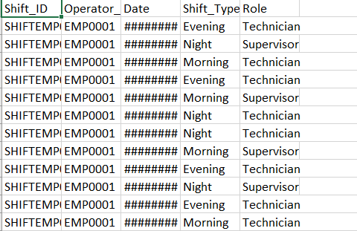
PROCESS PHASE
The following steps were taken to process the data
- Download the data from the company database
- Unzip the files
- Create a folder on desktop to house the files. Use appropriate file-naming conventions.
- Create subfolders for the .csv file and the .xlsx or Sheets file so that original copy of data is available. Move the downloaded files to the appropriate subfolder.
In SQL
- As soon as the data was cleaned, they were moved to progreSQL FOR QUERIES
- Tables were created and populated accordingly
- Queries were run in SQL to update some tables and creates joins.
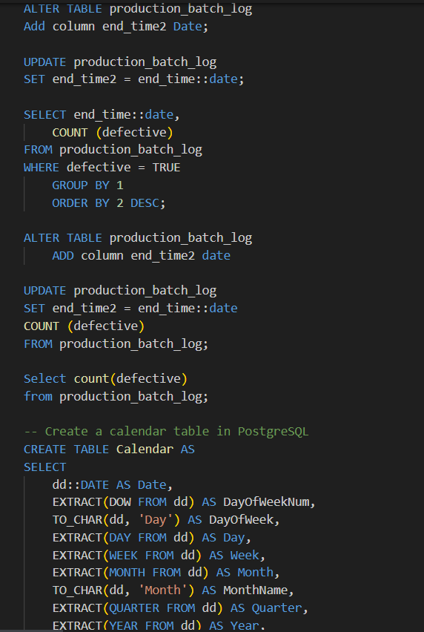
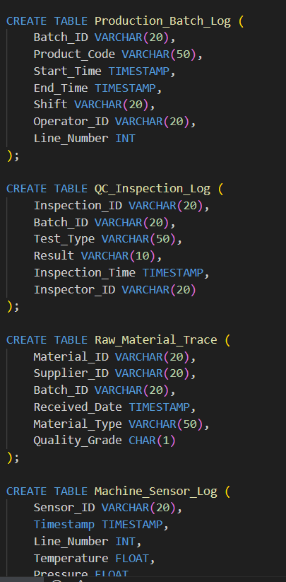
SHARE PHASE
After analyzing the data, Visualizations were made into three reports to support and present key findings. The visualizations below show visuals highlighting the different key areas.
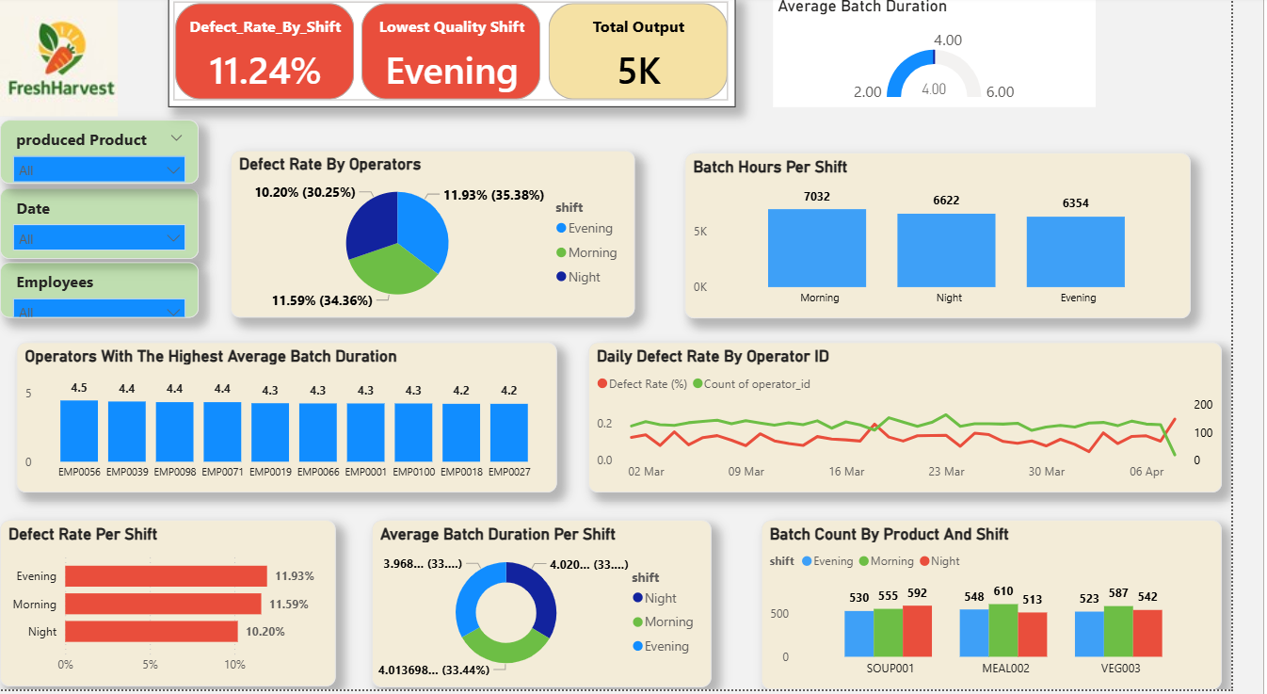
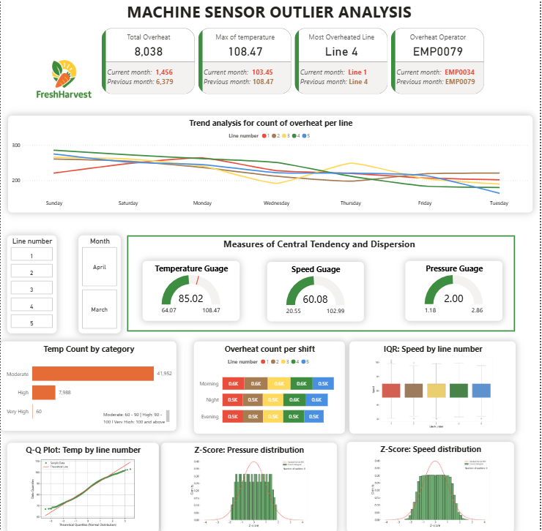
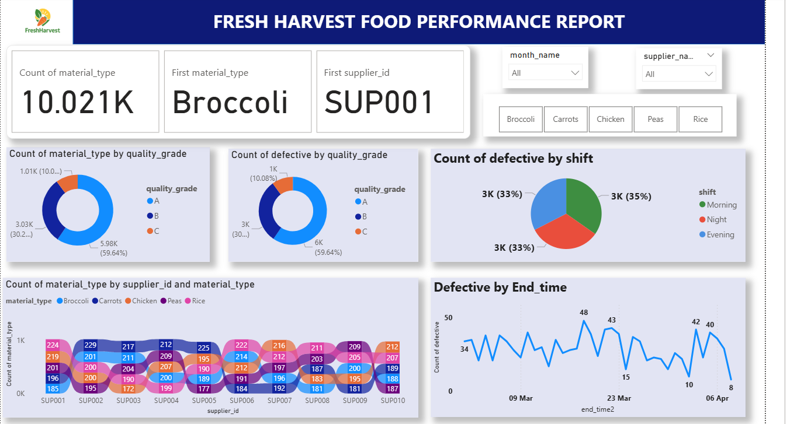
INSIGHTS AND RECOMMENDATIONS
Below are the insights generated from the analysis
- Evening Shift Has Lowest Quality
  - Highest defect rate: 11.93% vs. Morning (11.59%) and Night (10.20%).
  - Lowest average batch duration: 3.97 hours, possibly indicating rushed operations.
- Operators & Equipment Affecting Quality
  - EMP0056, EMP0039, EMP0098 have the highest batch durations (~4.5 hrs), possibly affecting throughput.
  - Overheating incidents are highest on Line 4 and involve EMP0079 frequently.
- Material Quality Concerns
  - Over 59% of materials are Grade A, yet defect distribution remains consistent across Grades A, B, and C.
  - SUP001 (Broccoli) is the top supplier by volume, but defect tracking by supplier is unclear.

RECOMMENDATIONS:
- Investigate Evening Shift Operations
  - Audit processes and retrain staff to improve quality and optimize batch timing.
  - Consider rebalancing production load toward shifts with better performance (e.g., Night shift).
- Focus on Equipment Maintenance and Operator Training
  - Prioritize inspection of Line 4 and ensure proactive maintenance.
  - Retrain or reassign EMP0079, who is linked to frequent overheat incidents.
- Refine Material Quality Controls
  - Enhance supplier-level defect tracking and feedback mechanisms.
  - Consider stricter quality checks or diversifying away from underperforming suppliers.

